- Version control system is a system that keeps track of changings in your project.
- Everytime when you make changes in your project, Version control takes snapshot of it.
- VCS is independent of the type of your project it only looks change in files of your project in the hard drive.
- Why use VCS? => 1. you lose the track of your changings within project in developmengt, 2. VCS is very useful in Collaboration development.
- In the absence of VCS you need to be save your previous version as a backup after every change in the project, which will result into bulk of data on your hard drive.
- There different types of VCS, Main Three are VSS, SVN and GIT.
- VSS :- VSS (Microsoft Visual sourcesafe) was an old VCS and it is now discontinued . It was used for small projects dealing in small team of three or four developers. The speciality about this VCS was that any user could have lock the file of the project on which he was currently working on.
- SVN : SVN ( Apache Subversion) is used for big projects and big teams and developer do not have to lock the file of the project for working on it.
But the draw back in this VCS is that no team member has full working copy of the project but there will be a centeralize server for the full working copy.
- GIT :- Git is a distributed version control system. Which means each user has its own full working copy. Advantage of this system is, if the centeraizred server get crash then any user system can be acted as a server since he has the full working copy of the project.
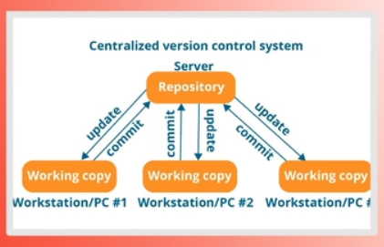
- Types of VCS clarifies that VCS basically have two kinds 1. centralized VCS and 2.Distributed VCS.
  - CVCS:-

One thing here is important to mention that every time when user make changes in the file, it will directly commit to centeral server and there will be no copy save on the user machine. Drawback of this is system is that it must requires network to commit change in the project.
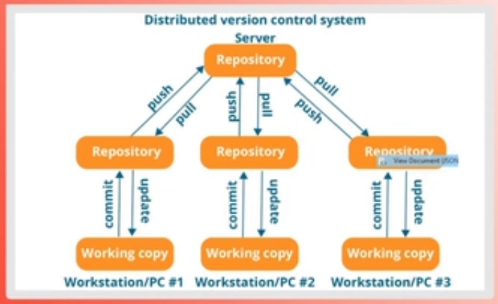
2. DVCS:-

each user have its own working cpy and he does not rely on the network. Changes can be commit on the user machine machine and DVCS will keep track of your changings.

